
Technical Coding Research Innovation, Navi Mumbai,
Maharashtra, India-410206

Build out AWS service architecture for Enterprise retail store with following assumptions: 1. 100+ stores 2. Inventory Management 3. Analytics services to be run by the stores.

Assignment Submitted for the requirement of
Technical Coding Research Innovation

For the Internship Project work done during

CLOUD COMPUTING USING AWS INTERNSHIP PROGRAM

by
1.Nivetha Sankarasubramanian : TCRIP01R05
2.Praveen Krishnakanth S:TCRIP01R03
3.Amaan Ali Khan B: TCRIP01R18
4.Naveen Kishore P : TCRIP01R02

Date: 3/01/2023 Rutuja Doiphode
CO-FOUNDER &CEO
TCR innovation.

`

PROBLEM STATEMENT

Inventory management helps companies identify which and how much stock to order at what time. It tracks inventory from purchase to the sale of goods. The practice identifies and responds to trends to ensure there's always enough stock to fulfill customer orders and proper warning of a shortage.

Inventory Management in Enterprise retail stores is the process of ensuring you have enough inventory to meet customer demand so that you don't end up with too little or too much merchandise. It's essential if you'd like to avoid situations where you run out of popular items or end up with excess items that nobody is buying.

Here, we have a customer who has 100 plus stores across the city and wants to store the data to run their application. Thereby, we need an infrastructure to execute these applications. So, we have used AWS services which provides very efficient and cost-effective way of building a robust service architecture. It provides EC2 instances like Lambda, S3 bucket etc. By using these services we have to build an architecture which explains this problem statement in a detailed form.

SOLUTION

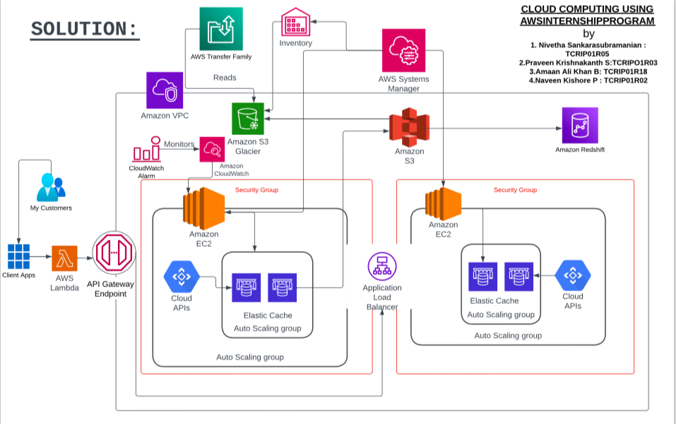

Now we have the solution for our problem statement, which we have represented as an architecture. Here we have to built an architecture for enterprise retail stores for 100+ stores.

Inventory management is the process of keeping track of the items in your warehouse. It involves knowing how much you have of a certain product and also how much you need. This is important because you don’t want inventory that’s not selling taking up valuable space in your warehouse; that costs money and could also lead to products expiring before they’re sold.
INFRASTRUCTURE AND SERVICES

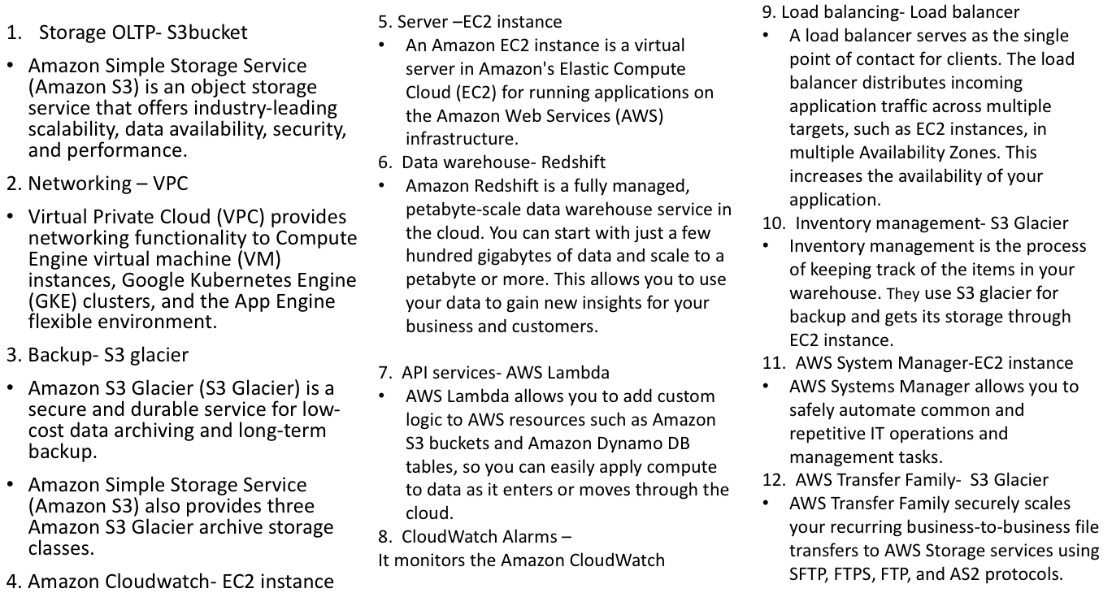

Here we have mentioned all the infrastructures and their corresponding services. Each infrastructure has used mainly three services like S3 Bucket, EC2 instances,S3 Glaciers. These are durable and secure services.

Buckets and the objects in them are private and can be accessed only if you explicitly grant access permissions. You can use bucket policies, AWS Identity and Access Management (IAM) policies, access control lists (ACLs), and S3 Access Points to manage access.

OUTCOME

- Allowing all the API requests would be dangerous as it might cause issue in security factor and Gateway provides a unified entry point across internal APIs. It allows us to control user access. And it enables security measures, like rate limiting, and applies security policies, like OAuth or JWT. An API gateway is especially important for securing micro services.
- The load balancer is making use of the two different EC2 instances with two different security groups which distributes the network or application traffic across a number of servers which is increasing the capacity (concurrent users ) and reliability of the applications which ensures that no one server is overworked, which could degrade the performance.
- The lambda is a server less, event-driven compute service that letting us run code for virtually any type of application or backend service without provisioning or managing servers. We can trigger Lambda from over 200 AWS services and software as a service (SaaS) applications.
- And only pay for what we use which is reducing the cost and also it’s allowing developers to build and run services without having to manage the underlying infrastructure.
- So to conclude the AWS service architecture for enterprise retail store will help in growth and tracking of the entire retail system. Since migrating to a server less architecture built on AWS—and with fully automated scaling—there’s a huge cut in its infrastructure costs and improved customers’ ticket-purchasing experience and also helped to innovate faster.
- We are using 100 plus store where we assume 500 users or admins those who work on business transaction (employees) , they will be working for all these 100 plus stores. The calculation we do here is 2 folks per store. So here we have 500 users working for 100 plus stores , for example if we have a store of 10 users the calculation will be 100*10 . So there will be 100 people working but not everyone will be working on inventory management, their jobs will be distributed amongst them .
- It will also track all the purchases and sells which will make it easier to stock the most sold good and other analytical calculations while keeping security in mind and prioritising it, we have also implemented highest security on the entire architecture.

ADVANTAGES OF COST OPTIMIZATION
- Cost optimization enables the free flow of data through the optimal usage of network system resources.
- Cost optimization tracks performance metrics, providing real-time reporting to help network managers proactively manage the network.
- Cost optimization provides analytics and predictive modeling so that network managers can determine the impact any changes to the architecture will have on the network before they are implemented.
- All these benefits add up to the most important benefit: driving greater network performance.

*----------------*---------------*------------------*

REFERENCES
- https://lucid.app/lucidchart/12e20fe2-230b-4ecf-b246-39522e35adb1/edit?beaconFlowId=39152507804E1E6A&invitationId=inv_78e8e483-4e02-4ef1-a515-57a5bc91cc4a&page=0_0#
- https://www.lucidchart.com/blog/how-to-use-lucidchart-cloud-insights-for-aws-five-pillars
- https://www.lucidchart.com/blog/all-about-inventory-management
- https://www.researchgate.net/publication/309109800_Enterprise_Architecture_Practice_in_Retail_Problems_and_Solutions

THANK YOU

1. Nivetha Sankarasubramanian : TCRIP01R05
2.Praveen Krishnakanth S:TCRIP01R03
3.Amaan Ali Khan B: TCRIP01R18
4.Naveen Kishore P : TCRIP01R02

